**//to calculate armstrong no.'s**

**#include<iostream.h>**

**#include<conio.h>**

**int arm_no(int); //protype for checking armstrong no.'s**

**void main()**

**{ clrscr();**

**cout<<"All Armstrong numbers below 1000 are:\n";**

**for(int i=1;i<=1000;i++)**

**{**

**if (arm_no(i)==1)**

**cout<<i<<endl; }**

**getch(); }**

**int arm_no (int n)**

**{ int digit,temp;**

**int sum=0,det=0;//determinant**

**temp=n;**

**while (temp!=0)**

**{digit=temp%10;**

**temp=temp/10;**

**sum+=(digit*digit*digit);}**

**if (sum==n)**

**{det=1;}**

**else**

**{det=0;}**

**return det; }**

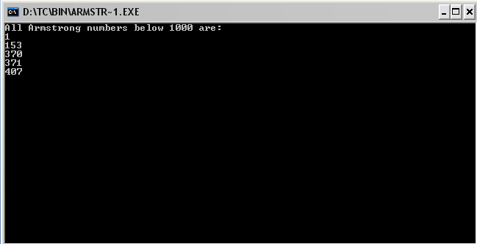

**//to concatenate two strings**

**#include<iostream.h>**

**#include<stdio.h>**

**#include<conio.h>**

**int main()**

**{ clrscr();**

**int i=0,j=0;**

**char str1[20],str2[20];**

**puts("Enter first string");**

**gets(str1);**

**puts("Enter second string");**

**gets(str2);**

**cout<<"Before concatenation the strings are\n";**

**puts(str1);**

**puts(str2);**

**while(str1[i]!='\0'){**

**i++; }**

**while(str2[j]!='\0')**

**{ str1[i++]=str2[j++]; }**

**str1[i]='\0';**

**cout<<"After concatenation the strings are\n";**

**puts(str1);**

**getch();**

**return 0; }**

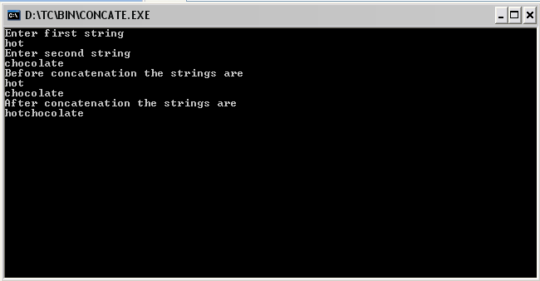

**//to accept no. of days and show the year and weeks**

**#include<iostream.h>**

**#include<conio.h>**

**void week_year(int days); //prototype for conversion of days**

**void main()**

**{**

**clrscr();**

**int days;**

**cout<<"enter no.of days"<<endl;**

**cin>>days;**

**week_year(days);**

**getch();**

**}**

**//function to convert days to weeks and years**

**void week_year(int days)**

**{**

**float years,weeks;**

**years=days/365;**

**weeks=days/7;**

**cout<<"no. of days="<<days<<endl;**

**cout<<"no of weeks="<<weeks<<endl;**

**cout<<"no. of years="<<years<<endl;**

**}**

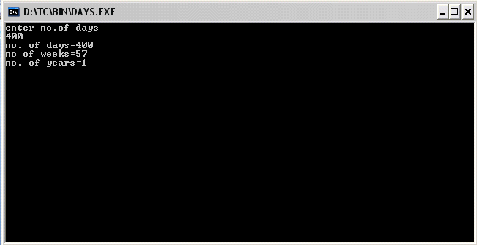

**//program to calculate the highest common factor**

**#include<iostream.h>**

**#include<conio.h>**

**int hcf(int a,int b)**

**{ int rem;**

**while(b!=0)**

**{ rem=a%b;**

**a=b;**

**b=rem; }**

**return a; }**

**int main()**

**{ clrscr()**

**int x,y;**

**cout<<"value of first no.=";**

**cin>>x;**

**cout<<"value of second no.=";**

**cin>>y;**

**cout<<endl;**

**cout<<"the highest common factor of "<<x<<"and"<<y<<"is:"<<hcf(x,y);**

**getch();**

**return 0;**

**}**

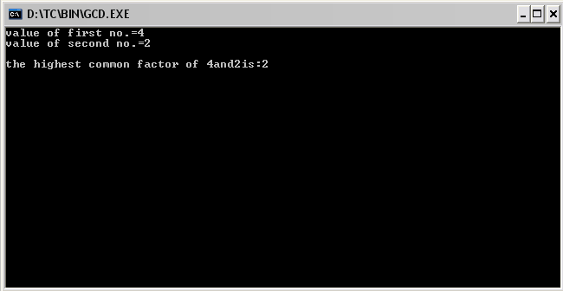

**//program of linear search**

**#include<iostream.h>**

**#include<conio.h>**

**void main()**

**{ clrscr();**

**const int size=5;**

**int i,pos,value, arr[size];**

**for(i=0;i<=size;i++)**

**{ cout<<"enter value of array"<<endl<<i+1<<”.”;**

**cin>>arr[i]; }**

**cout<<endl<<"enter value to be searched";**

**cin>>value;**

**pos=-1;**

**for(int c=0;c<size;c++)**

**{ if(arr[c]==value)**

**{ pos=c+1;**

**break; } }**

**if (pos>-1)**

**cout<<"element found at position:"<<pos;**

**else**

**cout<<"element not found";**

**getch();}**

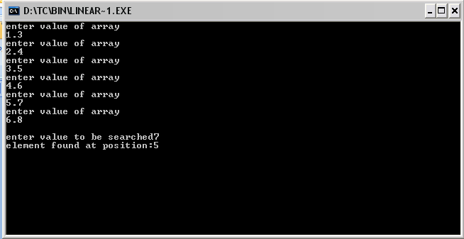

**// to show the lower and upper half ofmatrix**

**#include<iostream.h>**

**#include<conio.h>**

**void main()**

**{**

**clrscr();**

**int i,j,arr[3][3];**

**//input**

**cout<<"Enter array\n";**

**for(i=0;i<3;i++)**

**{for(j=0;j<3;j++)**

**{cin>>arr[i][j];}**

**}**

**//complete array**

**cout<<"Complete\n\n";**

**for(i=0;i<3;i++)**

**{for(j=0;j<3;j++)**

**{cout<<arr[i][j]<<" ";}**

**cout<<endl;**

**}**

**//lower half**

**cout<<"Lower half\n\n";**

**for(i=0;i<3;i++)**

**{for(j=0;j<=i;j++)**

**{cout<<arr[i][j]<<" ";}**

**cout<<endl;**

**}**

**//upper half**

**cout<<"Upper half\n\n";**

**for(i=0;i<3;i++)**

**{**

**for(j=0;j<i;j++)//for loop for spacing**

**{cout<<" ";}**

**for(j=i;j<3;j++)**

**{cout<<arr[i][j]<<" ";}**

**cout<<endl;**

**}**

**getch();**

**}**

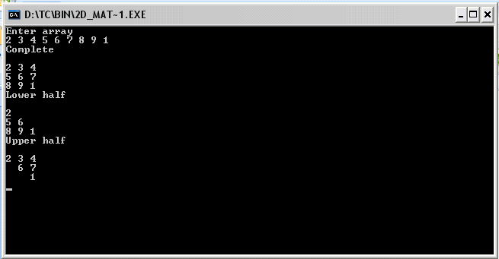

**//to calculate max and min marks of a student using array**

**#include<iostream.h>**

**#include<conio.h>**

**void main()**

**{ clrscr();**

**int marks[5];**

**int i,sum=0,avg=0;**

**int max=0,min=100;**

**for(i=0;i<5;i++)**

**{ cout<<"enter the marks os the student:"<<endl;**

**cin>>marks[i]; }**

**for(i=0;i<5;i++)**

**{ sum=sum+marks[i];**

**if (marks[i]>max)**

**{ max=marks[i]; }**

**if(marks[i]<min)**

**{ min=marks[i]; } }**

**avg=sum/10;**

**cout<<"average marks of student:"<<avg<<endl;**

**cout<<"maximum marks of student:"<<max<<endl;**

**cout<<"minimum marks of student:"<<min<<endl;**

**getch(); }**

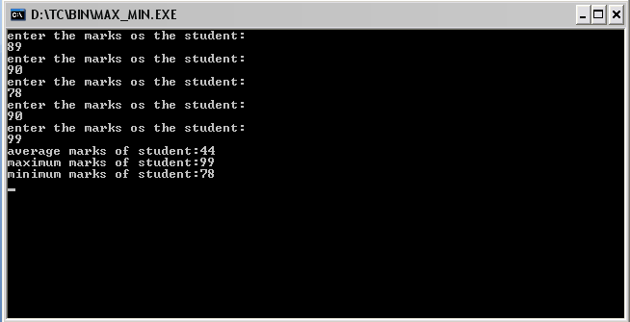

**//multiplication of matrix**

**#include<iostream.h>**

**#include<conio.h>**

**void main()**

**{ clrscr();**

**int a[2][2], b[2][2], c[2][2], i, j;**

**cout<<"enter the elements of matrix A ";**

**cout<<endl;**

**for(i=0;i<2;i++)**

**{ for(j=0;j<2;j++)**

**{ cin>>a[i][j]; }**

**}**

**cout<<endl<<"enter the elements of matrix B ";**

**cout<<endl;**

**for(i=0;i<2;i++)**

**{ for(j=0;j<2;j++)**

**{ cin>>b[i][j]; }**

**}**

**cout<<endl<<"you have entered the following matrices ";**

**cout<<endl<<"matrix A ";**

**for(i=0;i<2;i++)**

**{ for(j=0;j<2;j++)**

**{ cout<<a[i][j]<<" ";**

**cout<<endl; }**

**}**

**cout<<endl<<"matrix B ";**

**for(i=0;i<2;i++)**

**{ for(j=0;j<2;j++)**

**{ cout<<b[i][j]<<" ";**

**cout<<endl; }**

**}**

**cout<<"\n\nproduct of matrices are\n\n ";**

**for(i=0;i<2;i++)**

**{ for(j=0;j<2;j++)**

**for(int k=0;k<2;k++)**

**{ c[i][j]=0;**

**c[i][j]+=a[i][k]*b[k][j]; }**

**}**

**for (i=0;i<2;i++)**

**{ for(j=0;j<2;j++)**

**cout<<c[i][j]<<" ";**

**cout<<endl;**

**}**

**getch();**

**}**

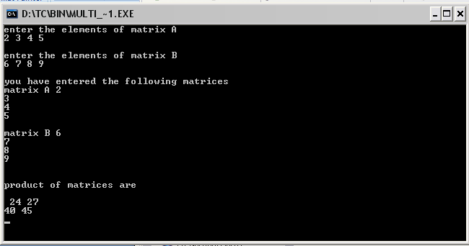

**//to check the no. of words**

**#include<iostream.h>**

**#include<conio.h>**

**#include<stdio.h>**

**void main( )**

**{**

**clrscr( );**

**char str[80];**

**int words=0;**

**cout<<"Enter a string:";**

**gets(str);**

**for(int i=0;str[i]!='\0';i++)**

**{**

**if (str[i]==' ')**

**words++; //Checking for spaces**

**}**

**cout<<"The number of words="<<words+1<<endl;**

**getch(); }**

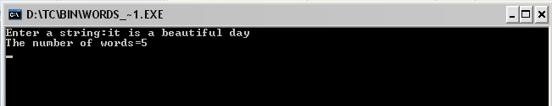

**// a palindrome**

**#include<iostream.h>**

**#include<conio.h>**

**#include<stdio.h>**

**void main( )**

**{**

**clrscr( );**

**char str[80];**

**cout<<"Enter a string:\n";**

**gets(str);**

**for(int l=0;str[l]!='\0';l++); //To find length of the string**

**for (int i=0;(i<l/2) && (str[i]==str[l-i-1]);i++);**

**if(i==l/2)**

**cout<<"It is a palindrome";**

**else**

**cout<<"It is not a palindrome";**

**getch();**

**}**

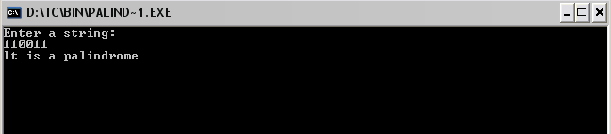

**//reverse of a string**

**#include<iostream.h>**

**#include<conio.h>**

**#include<stdio.h>**

**#include<string.h>**

**void main()**

**{ clrscr();**

**int l,i,k=0;**

**char str[80], word[80];**

**cout<<"enter any string "<<endl;**

**gets(str);**

**strcat(str," "); //concat a space at the end of string**

**for (i=0;str[i]!='\0';i++)**

**{ if(str[i]!=' ')**

**{ word[k]=str[i];**

**k=k+1; }**

**else**

**{ while (k>0)**

**{ cout<<word[--k]; }**

**cout<<str[i];**

**} }**

**getch();**

**}**

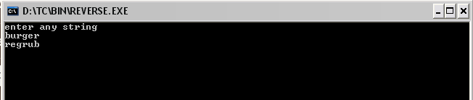

**//structure of books**

**#include <iostream.h>**

**#include <stdio.h>**

**#include<conio.h>**

**struct Books**

**{**

**char title[50];**

**char author[50];**

**char subject[100];**

**int book_id;**

**};**

**int main( )**

**{**

**struct Books Book1; // Declare Book1 of type Book**

**struct Books Book2; // Declare Book2 of type Book**

**clrscr();**

**cout<<"enter book name,book author,subject and id:";**

**// book 1 specification**

**gets(Book1.title);**

**gets(Book1.author);**

**gets(Book1.subject);**

**cin>>Book1.book_id;**

**// book 2 specification**

**gets(Book2.title);**

**gets(Book2.author);**

**gets( Book2.subject);**

**cin>>Book2.book_id ;**

**// Print Book1 info**

**cout << "Book 1 title : " << Book1.title <<endl;**

**cout << "Book 1 author : " << Book1.author <<endl;**

**cout << "Book 1 subject : " << Book1.subject <<endl;**

**cout << "Book 1 id : " << Book1.book_id <<endl;**

**// Print Book2 info**

**cout << "Book 2 title : " << Book2.title <<endl;**

**cout << "Book 2 author : " << Book2.author <<endl;**

**cout << "Book 2 subject : " << Book2.subject <<endl;**

**cout << "Book 2 id : " << Book2.book_id <<endl;**

**getch();**

**return 0;**

**}**

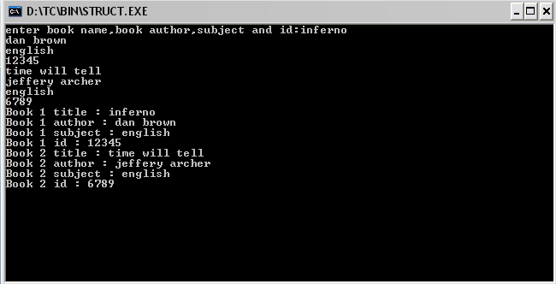

**//sum and subtraction of matrix**

**#include<iostream.h>**

**#include<conio.h>**

**void main()**

**{ clrscr();**

**int a[3][3], b[3][3], i, j, c[3][3],d[i][j];**

**cout<<"enter 1st matrix ";**

**for (i=0; i<3; i++)**

**{ for (j=0; j<3; j++)**

**{ cin>>a[i][j]; }**

**}**

**cout<<endl<<"enter 2nd matrix ";**

**for (i=0; i<3; i++)**

**{ for(j=0; j<3; j++)**

**{ cin>>b[i][j]; }**

**}**

**//addition of 2 matrices**

**for (i=0; i<3; i++)**

**{ for (j=0; j<3; j++)**

**c[i][j]= a[i][j] + b[i][j];**

**}**

**cout<<endl<<"sum of matrices : ";**

**for (i=0; i<3; i++)**

**{ for(j=0; j<3; j++)**

**{ cout<<" "<<c[i][j]; }**

**}**

**//subtraction of 2 matrices**

**for (i=0; i<3; i++)**

**{ for (j=0; j<3; j++)**

**d[i][j]= a[i][j] - b[i][j];**

**}**

**cout<<endl<<"subtraction of matrices : ";**

**for (i=0; i<3; i++)**

**{ for(j=0; j<3; j++)**

**{ cout<<" "<<d[i][j]; }**

**}**

**getch();**

**}**

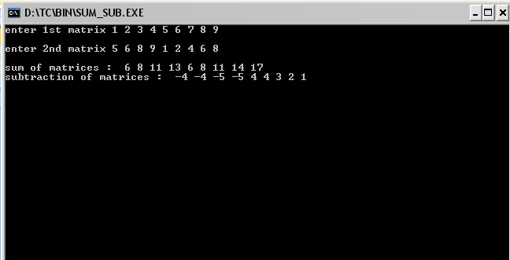

**//transpose of a matrix**

**#include<iostream.h>**

**#include<conio.h>**

**#include<stdio.h>**

**#include<math.h>**

**#include<string.h>**

**void main()**

**{**

**clrscr();**

**const int rsize=3;**

**const int csize=3;**

**int i,j,a[rsize][csize]={0},b[rsize][csize]={0};**

**cout<<"Enter array\n";**

**for(i=0;i<rsize;i++){**

**for(j=0;j<csize;j++){**

**cin>>a[i][j];**

**} }**

**cout<<"Matrix is\n";**

**for(i=0;i<rsize;i++){**

**for(j=0;j<csize;j++)**

**{ cout<<a[i][j]<<" "; }**

**cout<<endl; }**

**//calculation**

**for(i=0;i<rsize;i++){**

**for(j=0;j<csize;j++){**

**b[j][i]=a[i][j];**

**}}**

**cout<<"Transpose is\n";**

**for(i=0;i<csize;i++){**

**for(j=0;j<rsize;j++){**

**cout<<b[i][j]<<" ";**

**}cout<<endl;**

**}**

**getch();**

**}**

